Megan Watkins
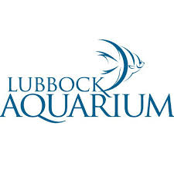
To: Reporter@LubbockJournal.news
5212 29th Drive
Lubbock, TX 79464

Admin@lubbockaquarium.org
Subject: Lubbock Aquarium to Open Soon
NEWS RELEASE
For immediate release

Oct. 29, 2019
Lubbock Aquarium Opening Soon
LUBBOCK, Texas - Sharks, octopus and star fish galore! The Lubbock Aquarium is set to open in a few years at the corner of York Avenue and 29th Drive. The West Texas aquarium is a nonprofit and intended to bring the beauty of the ocean to Lubbock

The mission of the aquarium is to educate and share an appreciation for wildlife conservation. Lubbock aquarium has teamed with Texas Tech STEM program to immerse students in a hands-on experience with the ocean. The nonprofit aquarium offers many volunteer opportunities, and includes a student’s ambassador program. To volunteer, click here.

Exhibits that will be on display at the highly anticipated aquatic museum will split between interactive and educational. Some of the animals that will be featured include alligators, crocodiles, river otters and a butterfly garden attached. The state of the art facility is partnering with marine experts to insure an inspiring and engaging experience.

Lubbock natives, Kai and Jim Evans, founded Lubbock Aquarium recognizing the educational and conservation efforts it could bring to the West Texas city. The Lubbock Aquarium is asking businesses to partner with the construction of the facility.

Donations to the West Texas aquarium are tax deductible and sponsorships may range from $75-$1,000 monthly. For more information regarding becoming a business partner email admin@lubbockaquarium.org.

###

For more information please contact:
Lubbock Aquarium
(888) 888-8888
Lubbock Aquarium website
Facebook
Twitter

